Anastasia Eastridge
3211 Forbes Ct
Cheyenne, WY 82009
503-267-5048 (cell)
bunraiteiw@yahoo.com (email)
Early entries close on
Saturday August 26, 2023
at 5:00 p.m.

.

Directions to Trial Site

Island Grove Park Entrance at 11th Avenue & North of D Street

- From the north –Hwy 85 South to 11th Ave Exit – South on 11th Ave to entrance
- Rom the south – Hwy 85 north to 5th Street Exit – West on 5th Street to 11th Ave – North on 11th Ave to entrance
- East or West – Hwy 34 to 11th Ave Exit – North on 11th Ave to entrance

PREMIUM LIST, ASFA SANCTIONED
ASFA SANCTIONED SPECIALTY LURE TRIAL, REGION 3

This premium available on-line at http://rmiwa.org/SpecialtyASFA.html
Early entries close on Saturday, August 26, 2023, at 5:00 p.m.
at the Field Trial Secretary’s address
Day of trial entries close at roll call the day of the trial at the FTS desk.
(Substitutions by the same owner will be allowed by Roll Call the day of the trial)

2023 RMIWA
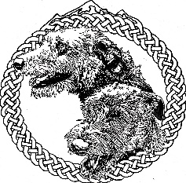

30th Specialty &
50th Anniversary

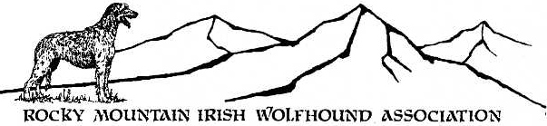

WEDNESDAY August 30, 2023
14th Ave. North & D St., Island Grove Park Soccer Fields, Greeley, CO

Entry Fees:
Early entry: $20.00 for first hound, $12.00 each add'l hound-same owner.
Day of Trial entry: $25.00 per hound
Non-Regular stakes (Breeder, Kennel, Bench CH) $5.00 per unit

Payments via PayPal accepted
Please add $2 per entry to the entry fee and send to Treasurer@RMIWA.org
Send a copy of the PayPal receipt along with your entries to the Field Trial Secretary
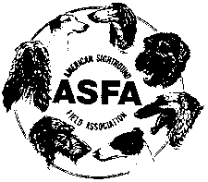

Permission has been granted by the American Sighthound Field Association for the holding of this event under American Sighthound Field Association Rules and Regulations.

Audrey Silverstein, Chairman
ASFA Scheduling Committee
ROCKY MOUNTAIN IRISH WOLFHOUND ASSOCIATION
OFFICERS AND DIRECTORS
President: Sarah Shorey Treasurer: Amy Solberg
Vice President: Michael Hussey Secretary: Melissa Scofield
Board of Directors: Anne Dougherty, Rn Graves, Denise Shorey,
Andrea Vitullo

JUDGES and their assignments
Irish Wolfhounds
Frank Cassano, LaSalle, CO
Jocelyne Gagne, Welland, ON, Canada

FIELD COMMITTEE
Field Chairman
Michael Hussey, 36895 View Ridge Drive, Elizabeth, CO 80107
303-549-5584 (cell) dinnree@skybeam.com (email)

Field Secretary
Anastasia Eastridge
3211 Forbes Ct
Cheyenne, WY 82009
503-267-5048 (cell) bunraiteiw@yahoo.com (email)

Lure Operator – Michael Hussey

RIBBON PRIZES & TROPHIES
First Place Blue Rosette Second Place Red Rosette Third Place Yellow Rosette Fourth Place White Rosette NBQ Green Rosette
Best of Breed Purple & Gold Rosette Best Single stake winner Navy/gold ribbon
All trophies offered by the RMIWA and its generous donors
Best of Breed Logo picnic basket
Kennel Stake Logo drinkware
Breeder Stake Logo drinkware
Highest Scoring Bench Champion Logo drinkware
1st Place All Stakes: Lg logo drinkware 2nd-NBQ All Stakes Logo drinkware
Open Stake trophies
FCh Stake trophies
Veteran Stake trophies
Single Stake trophies

Perpetual Trophies
Best of Breed - Bronze IW Sculpture on Wood Base - Donated by Kathy & Stu Dykstra
Memory Book of Past BOB winners - Multiple donors

Challenge Trophies
Open 1st place - Silver-plate Bowl on Wood Base - Prairie Creek Trophy - Jim & Connie Smalley
Field Champion 1st place - Silver-plate Bowl on Wood Base - Karontara Trophy – Tracey & Leonard Luty
Veteran 1st place - Trophy– Rockhart Noor Trophy – Shelley & Tom Hood

TRIAL HOURS
2:30 pm until completed Day of Trial entries close at 3:30 p.m.
Roll call: Promptly at 4:00 PM
Only purebred Irish Wolfhounds may be entered in the regular stakes in ASFA lure field trials. All hounds must be not less than one year old on the day of the trial. All entries shall be individually registered with the AKC (ILP/PAL included), the NGA, the UKC, the FCI, an ASFA-recognized foreign or ASFA Board approved registry, or possess a CRN from the SPDBS. A photocopy of acceptable registry must be submitted with each hound’s first ASFA field trial entry; this requirement is waived for hounds registered with the NGA.

ENTRIES WILL NOT BE ACKNOWLEDGED BY MAIL OR TELEPHONE. LATE, INCOMPLETE, UNSIGNED OR CONDITIONAL ENTRIES WILL NOT BE ACCEPTED.

REGULAR STAKES OFFERED:
OPEN STAKE: Any eligible Irish Wolfhounds excluding ASFA Field Champions of record.
FIELD CHAMPION STAKE: Any ASFA Field Champion Irish Wolfhounds.
VETERAN STAKE: Any eligible Irish Wolfhounds whose age is at least five years.
SINGLE STAKE: Any eligible Irish Wolfhound including those disqualified to run in other stakes. Each hound runs alone. Not eligible for Best of Breed or Best in Field. Hounds are eligible to earn TCP and CPX titles from the Singles stake. Provisional breeds are not eligible for these titles.

The entry for each hound entering the Open, Veteran or Single Stake for the first time MUST include a completed & signed ASFA Certification Form or Waiver Form (with proof of title) and a copy of the hound’s registration certificate

NON-REGULAR STAKES
KENNEL STAKE: An entry shall consist of two Irish Wolfhounds, designated at time of entry, in one of the regular stakes being owned and kenneled by the same person.
BREEDER STAKE: Designated at time of entry, two Irish wolfhounds bred by the same individual.
BENCH CHAMPION: For any Irish Wolfhound with proof on file with the ASFA of a conformation champion title from the AKC, CKC or both or a conformation grand champion title from the UKC. To enter this stake, the owner must attach a copy of the hound's show championship certificate to the entry form.

CONDITIONS OF ENTRY:
All entries must be one year or older on the day of the trial. Stakes will be split into flights by public random draw if the entry in any regular stake is 20 or more. Bitches in season, lame hounds and hounds with breed disqualifications will be excused at roll call. Spayed, neutered, monorchid or cryptorchid hounds without breed disqualifications may be entered. Hounds with breed disqualifications are not eligible to enter Hounds not present at the time of roll call will be scratched. All hounds will run twice, in trios if possible or braces (except in the Single Stake), unless excused, dismissed or disqualified.

Please Contact Michael Hussey - Field Trial Chairman about Certification runs

REFUND POLICY - Refunds will be allowed for lame hounds, bitches in season and breed disqualifications as determined at the trial inspection. Full refunds are allowed for entries cancelled for any reason prior to the EARLY entry closing date and time.

GENERAL INFORMATION and POLICIES: A penalty of $5.00 will be assessed for any loose hound not competing in the course in progress. Battery powered continuous loop machine will be used. Lure will consist of white plastic strips or a combination of black and white plastic strips. Back-up equipment will be available. BRING WATER AND SHADE FOR YOUR HOUNDS. Bathrooms on site. WARNING: It is advised that all hounds entered be in top physical condition due to the altitude and rigorous conditions of the course. ALL HOUNDS RUN AT THE OWNER’S SOLE RISK.

COURSE PLAN: The RMIWA reserves the right to alter the course diagram ONLY as required by weather and/or field conditions on the day of the trial. The area is fenced. TOTAL - 660 yards

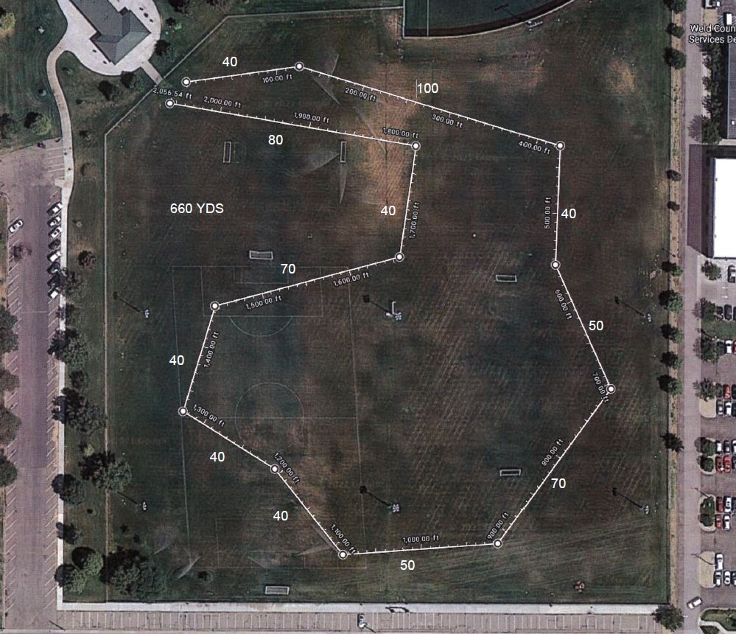

VETERINARY SERVICES / On-Call / 24 / 7
PETS EMERGENCY TREATMENT SERVICE (PETS) …… (970) 339 8700
3629 23rd Ave – Evans CO 80620
Directions from Island Grove Park: See Map in the show show premium.
Exit IGP onto 11th Ave – South on 11th Ave to 9th Street – West on 9th Street to 23rd Ave – South on 23rd Ave to the clinic, located on the west side of the street (1/2 mile south of Wal-Mart) in the Village Centre of the Landings mini-mall.
Exhibitors will be responsible for all charges they incur in seeking veterinary treatments

The RMIWA Wishes to thank its generous donors. Without them we would not be able to offer fine prizes for our specialty trial.

Regular & Non-Regular Stakes

Perpetual Trophy
Kathy & Stu Dykstra

Challenge Trophies
Shelley & Tom Hood
Tracey & Leonard Luty
Jim & Connie Smalley
________________________________________________

Please come to the:
RMIWA Specialty Shows (2) & Obedience & Rally Trial
September 1 & 2 2022
Island Grove Regional Park
Greeley, CO

Show Secretary: Sue Scott
Champion Dog Events
28485 Mid Jones Road
Calhan, CO 80808
Phone (719)338-0065
www.championdogevents.com

AMERICAN SIGHTHOUND FIELD ASSOCIATION
HOUND CERTIFICATION
Rule effective October 1, 1994: Ch. V, Sec. 4 (a) OPEN STAKE: To be eligible to enter the open stake, a hound must have been certified by a licensed judge within the year preceding the closing date for the entry or have previously competed in the Open Stake. This eligibility requirement also applies to a hound entered in the Veteran Stake, which has not competed in Open previously. Please complete this portion of this form and attach it to the entry form for the hound’s first entry, including an entry for a Fun Trial.

Registered Name of Hound: ___________________________________________________

Registration Number: _________________________ Breed: ________________________

Registered Owner’s Name: ___________________________________________________

I hereby certify that on (date) __________________, the above named hound completed a lure course of at least 500 yards, running with another hound of the same breed (or another breed with a similar running style). During the course the above named hound showed no inclination to interfere with the other hound. I further certify that I am a licensed judge for the ASFA.

Name of Licensed Judge: ____________________________________________________

Signature:____________________________________________ Date: ________________
I hereby certify that the hound running in the certification course is the hound identified above and that information provided on this form is true and correct.

Signature:____________________________________________ Date: _________________
Owner or Authorized Agent of Hound
This certification form must be attached to the entry form the first time this hound is entered in an open, limited, or veteran stake. Any hound entered in open, limited, or veteran (as a first time entered hound), which has not been certified, shall be declared ineligible by the records coordinator and shall forfeit any points and placements awarded.
PLEASE RETAIN A COPY FOR YOUR RECORDS.
AMERICAN SIGHTHOUND FIELD ASSOCIATION
HOUND CERTIFICATION WAIVER
Waiver of Requirement: This requirement will be waived for a hound that has earned a lure coursing or racing title from another recognized organization, if such title requires competition, and if a waiver for such title has been approved by the ASFA, or a CKC Hound Certification Form. If your hound qualifies for a waiver, complete this portion of this form and attach it to your entry form. Proof of waivers must accompany this certification form.

Registered Name of Hound: __________________________________________________

Registration Number: _________________________ Breed: ________________________

Registered Owner’s Name: ___________________________________________________
CKC: FCH FCHX
AKC: QC SC FC
Hound Certification previously submitted.
I hereby certify that the hound identified above has completed the requirements for the title indicated above (or that the required Certification was previously submitted) and that the information provided on this form is true and correct.

Signature: _______________________________________________ Date: ______________
Owner or Authorized Agent of Hound

AMERICAN SIGHTHOUND FIELD ASSOCIATION
HOUND CERTIFICATION
Rule effective October 1, 1994: Ch. V, Sec. 4 (a) OPEN STAKE: To be eligible to enter the open stake, a hound must have been certified by a licensed judge within the year preceding the closing date for the entry or have previously competed in the Open Stake. This eligibility requirement also applies to a hound entered in the Veteran Stake, which has not competed in Open previously. Please complete this portion of this form and attach it to the entry form for the hound’s first entry, including an entry for a Fun Trial.

Registered Name of Hound: ___________________________________________________

Registration Number: _________________________ Breed: ________________________

Registered Owner’s Name: ___________________________________________________

I hereby certify that on (date) __________________, the above named hound completed a lure course of at least 500 yards, running with another hound of the same breed (or another breed with a similar running style). During the course the above named hound showed no inclination to interfere with the other hound. I further certify that I am a licensed judge for the ASFA.

Name of Licensed Judge: ____________________________________________________

Signature:____________________________________________ Date: ________________
I hereby certify that the hound running in the certification course is the hound identified above and that information provided on this form is true and correct.

Signature:____________________________________________ Date: _________________
Owner or Authorized Agent of Hound
This certification form must be attached to the entry form the first time this hound is entered in an open, limited, or veteran stake. Any hound entered in open, limited, or veteran (as a first time entered hound), which has not been certified, shall be declared ineligible by the records coordinator and shall forfeit any points and placements awarded.
PLEASE RETAIN A COPY FOR YOUR RECORDS.
AMERICAN SIGHTHOUND FIELD ASSOCIATION
HOUND CERTIFICATION WAIVER
Waiver of Requirement: This requirement will be waived for a hound that has earned a lure coursing or racing title from another recognized organization, if such title requires competition, and if a waiver for such title has been approved by the ASFA, or a CKC Hound Certification Form. If your hound qualifies for a waiver, complete this portion of this form and attach it to your entry form. Proof of waivers must accompany this certification form.

Registered Name of Hound: __________________________________________________

Registration Number: _________________________ Breed: ________________________

Registered Owner’s Name: ___________________________________________________
CKC: FCH FCHX
AKC: QC SC FC
Hound Certification previously submitted.
I hereby certify that the hound identified above has completed the requirements for the title indicated above (or that the required Certification was previously submitted) and that the information provided on this form is true and correct.

Signature: _______________________________________________ Date: ______________
Owner or Authorized Agent of Hound

OFFICIAL AMERICAN SIGHTHOUND FIELD ASSOCIATION ENTRY FORM

ROCKY MOUNTAIN IRISH WOLFHOUND ASSOCIATION
WEDNESDAY, August 30, 2023
Early entries close Saturday August 26, 2023, at 5:00 p.m.
$20.00 for 1st dog, $12.00 ea. add’l dog same owner. $5.00 Non-Regular Stakes
Day of Trial entries close at Roll Call on the day of the trial, $25.00 per dog.
Make checks payable to RMIWA and mail with entry to:
3211 Forbes Ct, Cheyenne, WY 82009

Fee Paid ______ The Field Secretary cannot accept conditional, unsigned, incomplete or unpaid entries; please check your completed entry carefully.
Breed: IRISH WOLFHOUND | Call Name:
Registered Name of Hound:

Stake  Open FCH Veteran Single |  | Additional Stakes:  Kennel Breeder Bench
Registration Number: (please write in registering body before number)

If possible, please  separate my hounds | Date of  Birth: | Sex:  Dog Bitch
Name of actual owner(s):

Address: |  | Phone:
City: |  | State: | Zip:
E-Mail (Optional): |  | (Optional) Region of Residence:
Check if this is the first ASFA trial for this hound. Attach a Hound Certification or waiver if entered in Open, Veterans, Limited.
Check if this is a first time entry, a copy of the official Registration of this hound must accompany this entry unless NGA.
Check if any information has changed since the last ASFA trial entry. Regarding
Check if this hound has been dismissed within the last 6 trials entered. Must be marked in order to qualify for a “clean” trial requirement.
I CERTIFY that I am the actual owner of this dog, or that I am the duly authorized agent of the actual owner whose name I have entered above. In consideration of the acceptance of this entry and the opportunity to have this dog judged and to win prize money, ribbons, or trophies, I (we) agree to abide by the rules and regulations of the American Sighthound Field Association in effect at the time of this lure field trial, and by any additional rules and regulations appearing in the premium list for this lure field trial. I (we) agree that the club holding this lure field trial has the right to refuse this entry for cause, which the club shall deem to be sufficient. I (we) agree to hold this club, its members, directors, governors, officers, agents or other functionaries, any employees of the aforementioned parties and the owner(s) of the trial premises or grounds harmless from any claim for loss or injury which may be alleged to have been caused directly or indirectly to any person or thing by the act of this dog while in or upon the lure field trial premises or grounds or near any entrance thereto and I (we) personally assume all responsibility and liability for any such claim, and I (we) further agree to hold the aforementioned parties harmless from any claim loss of this dog by disappearance, theft damage or injury be caused or alleged to be caused by the negligence of the club or any of the aforementioned parties or by the negligence of any person or any other cause or causes. I (we) certify and represent that the dog entered is not a hazard to person or other dogs. This entry is submitted for acceptance of the forgoing representations and agreements.

SIGNATURE of owner or his agent
duly authorized to make this entry ___________________________________________________________________

EF-A ~ rev 07-12 ©
OFFICIAL AMERICAN SIGHTHOUND FIELD ASSOCIATION ENTRY FORM
ROCKY MOUNTAIN IRISH WOLFHOUND ASSOCIATION
WEDNESDAY, August 30, 2023
Early entries close Saturday August 26, 2023, at 5:00 p.m.
$20.00 for 1st dog, $12.00 ea. add’l dog same owner. $5.00 Non-Regular Stakes
Day of Trial entries close at Roll Call on the day of the trial, $25.00 per dog.
Make checks payable to RMIWA and mail with entry to:
3211 Forbes Ct, Cheyenne, WY 82009

Fee Paid ______ The Field Secretary cannot accept conditional, unsigned, incomplete or unpaid entries; please check your completed entry carefully.
Breed: IRISH WOLFHOUND | Call Name:
Registered Name of Hound:

Stake  Open FCH Veteran Single |  | Additional Stakes:  Kennel Breeder Bench
Registration Number: (please write in registering body before number)

If possible, please  separate my hounds | Date of  Birth: | Sex:  Dog Bitch
Name of actual owner(s):

Address: |  | Phone:
City: |  | State: | Zip:
E-Mail (Optional): |  | (Optional) Region of Residence:
Check if this is the first ASFA trial for this hound. Attach a Hound Certification or waiver if entered in Open, Veterans, Limited.
Check if this is a first time entry, a copy of the official Registration of this hound must accompany this entry unless NGA.
Check if any information has changed since the last ASFA trial entry. Regarding
Check if this hound has been dismissed within the last 6 trials entered. Must be marked in order to qualify for a “clean” trial requirement.
I CERTIFY that I am the actual owner of this dog, or that I am the duly authorized agent of the actual owner whose name I have entered above. In consideration of the acceptance of this entry and the opportunity to have this dog judged and to win prize money, ribbons, or trophies, I (we) agree to abide by the rules and regulations of the American Sighthound Field Association in effect at the time of this lure field trial, and by any additional rules and regulations appearing in the premium list for this lure field trial. I (we) agree that the club holding this lure field trial has the right to refuse this entry for cause, which the club shall deem to be sufficient. I (we) agree to hold this club, its members, directors, governors, officers, agents or other functionaries, any employees of the aforementioned parties and the owner(s) of the trial premises or grounds harmless from any claim for loss or injury which may be alleged to have been caused directly or indirectly to any person or thing by the act of this dog while in or upon the lure field trial premises or grounds or near any entrance thereto and I (we) personally assume all responsibility and liability for any such claim, and I (we) further agree to hold the aforementioned parties harmless from any claim loss of this dog by disappearance, theft damage or injury be caused or alleged to be caused by the negligence of the club or any of the aforementioned parties or by the negligence of any person or any other cause or causes. I (we) certify and represent that the dog entered is not a hazard to person or other dogs. This entry is submitted for acceptance of the forgoing representations and agreements.

SIGNATURE of owner or his agent
duly authorized to make this entry ___________________________________________________________________

EF-A ~ rev 07-12 ©

Information & Policies

- Restrooms on site.
- BRING WATER AND SHADE FOR YOUR HOUNDS.
- Bring FOOD – none offered by the Club.
- Smoking of any kind is prohibited on the field,
- PICK UP AFTER YOUR DOG AND YOURSELF!
- EQUIPMENT: Type of lure machine: battery-powered continuous loop system. Back-up equipment will be available. Type of lures: highly visible plastic strips.
- A $20.00 fee will be assessed for any returned checks. Persons exhibiting conduct detrimental to ASFA/CLCA/ any hound(s)/other person(s) will be asked to leave the trial site.
- There will be a $5.00 fine for any owner who does not clean up after his/her hound and for any loose hound not competing in the course in progress.

HELP!!!

We will need some help setting up and taking down the course Any help will be DEEPLY appreciated.

Thank you.

